Project Planning Phase

Project Planning Template (Product Backlog, Sprint Planning, Stories, Story Points)
Date | 26 September 2026
Team ID | SWTID-2026-4512
Project Name | AI Study Buddy
Maximum Marks | 5 Marks

Product Backlog, Sprint Schedule, and Estimation
The table below outlines the product backlog for Study Buddy, organized by sprint, functional requirement (epic), and user story, along with story point estimation and priority.
Sprint | Functional Requirement (Epic) | User Story Number | User Story / Task | Story Points | Priority | Team Members
Sprint-1 | Registration | USN-1 | As a student, I can register for the application by entering my name, email, and password. | 2 | High | [Team Member]
Sprint-1 |  | USN-2 | As a user, I will receive a confirmation response once I have successfully registered for the application. | 1 | Medium | [Team Member]
Sprint-1 |  | USN-3 | As a user, my password is securely encrypted (bcrypt) before being stored in the database. | 1 | High | [Team Member]
Sprint-1 | Login & Authentication | USN-4 | As a user, I can log into the application by entering my email and password and receive a JWT access token. | 2 | High | [Team Member]
Sprint-1 |  | USN-5 | As a user, I can refresh my access token using a refresh token without logging in again. | 1 | Medium | [Team Member]
Sprint-1 |  | USN-6 | As a user, I can log out of the application, ending my session. | 1 | Low | [Team Member]
Sprint-2 | Study Material Management | USN-7 | As a student, I can upload study material (PDF/text) to the platform. | 3 | High | [Team Member]
Sprint-2 |  | USN-8 | As a student, I can view a list of my previously uploaded study materials. | 2 | Medium | [Team Member]
Sprint-2 |  | USN-9 | As an admin, I can view all study materials uploaded by all users. | 2 | Medium | [Team Member]
Sprint-3 | AI Summary Generation | USN-10 | As a student, I can generate a concise AI summary of my uploaded study material using the Gemini API. | 3 | High | [Team Member]
Sprint-3 |  | USN-11 | As a student, I can view and save my generated summaries for later reference. | 2 | Medium | [Team Member]
Sprint-3 | AI Flashcard Generation | USN-12 | As a student, I can generate flashcards from my study material for active recall practice. | 3 | High | [Team Member]
Sprint-3 |  | USN-13 | As a student, I can review my saved flashcards for a specific study material. | 2 | Medium | [Team Member]
Sprint-4 | AI Quiz Generation | USN-14 | As a student, I can generate a multiple-choice quiz based on my study material to test my knowledge. | 3 | High | [Team Member]
Sprint-4 |  | USN-15 | As a student, I can view my quiz results after attempting a quiz. | 2 | Medium | [Team Member]
Sprint-4 | AI Study Plan Generation | USN-16 | As a student, I can generate a personalized study plan based on my exam date and available study time. | 3 | High | [Team Member]
Sprint-4 | Admin Dashboard | USN-17 | As an admin, I can view and manage all registered users. | 2 | Medium | [Team Member]
Sprint-4 |  | USN-18 | As an admin, I can monitor AI service usage and system activity logs. | 2 | Low | [Team Member]

Project Tracker, Velocity & Burndown Chart
Sprint | Total Story Points | Duration | Sprint Start Date | Sprint End Date (Planned) | Story Points Completed (as on Planned End Date) | Sprint Release Date (Actual)
Sprint-1 | 8 | 6 Days | 01 Oct 2026 | 06 Oct 2026 | 8 | 06 Oct 2026
Sprint-2 | 7 | 6 Days | 07 Oct 2026 | 12 Oct 2026 | 7 | 12 Oct 2026
Sprint-3 | 10 | 6 Days | 13 Oct 2026 | 18 Oct 2026 | 10 | 18 Oct 2026
Sprint-4 | 12 | 6 Days | 19 Oct 2026 | 24 Oct 2026 | 12 | 24 Oct 2026

Velocity
Across the four sprints, the Study Buddy team completed a total of 37 story points over 24 days (four 6-day sprints), giving an average velocity of approximately 9.25 story points per sprint, or roughly 1.5 story points per day.
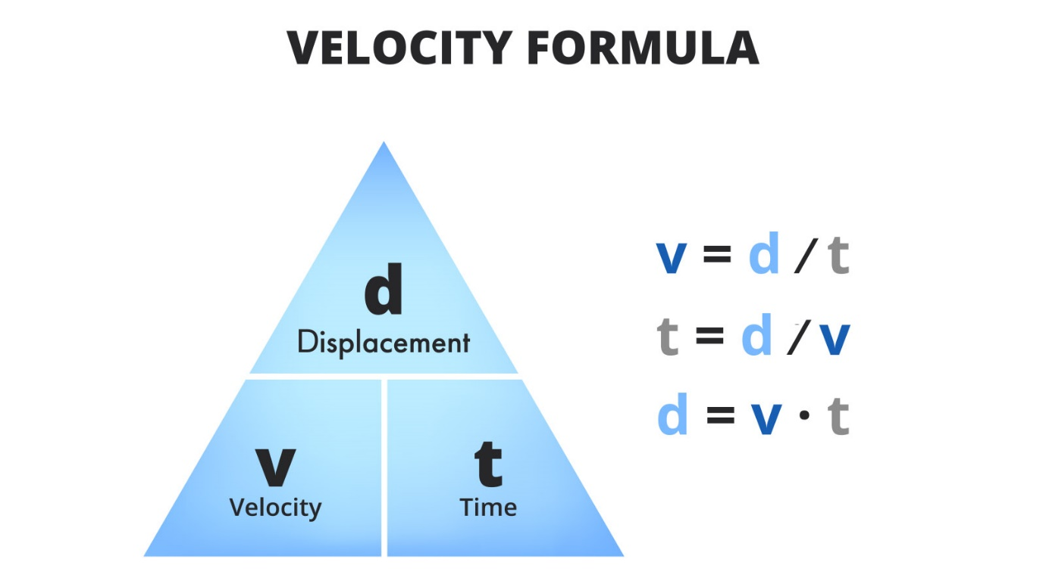
Burndown Chart
A burndown chart is a graphical representation of work remaining versus time. It is used in agile methodologies such as Scrum to track a team's progress toward completing the sprint backlog. For Study Buddy, a burndown chart was maintained for each sprint to visualize remaining story points against the planned sprint duration.

